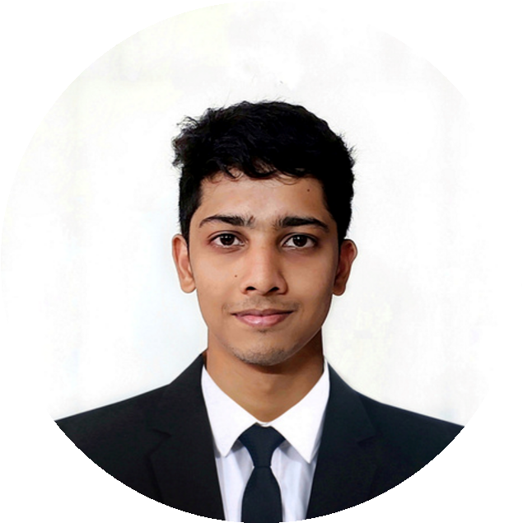

**AREA OF INTREST**

DESIGINING AND DEVELOPMENT

**EDUCATION**

**PANIMALAR ENGINEERING COLLEGE**

*B.E (Mechanical Engineering)*

*CGPA: 8.89*

*2020-2024*

**DONBOSCO MAT.HT.SEC SCHOOL**

**LANGUAGE**

English.

Tamil.

**PROJECTS**

HSC: 64.83%

SSLC: 85%

**RAGUL S.V**

Portable Bench Grinding Machine.

Jute/Polyester Hybrid Composite.

Project on 3D printing Machines.

Project on HCCI Engines.

I am a Mechanical Engineer, qualified

From a reputed college in Chennai. I

wanted to explore my dedication and

learned skills through an

Organization engaged in my

Field on interest to achieve my vision.

I am very much interested in Team

Work. I am passionate and dedicated

Towards my work and my studies

**PROFESSIONAL PROFILE**

**CONTACT ME**

91+ 9791133406

ragul7villa@gmail.com

No72. Rajaji 5th Street

Thanikachalam nagar

E-Block

Ponniammanmedu

Chennai-600110

**OTHER ACHIEVEMENTS**

District Football player.

Athletic Super Senior Champion

In Higher Secondary School level.

NON-TECHNICAL ROLES

TECHNICAL CODING

**TECHNICAL SKILLS**

Microsoft Office.

SQL Basics

Python Basics